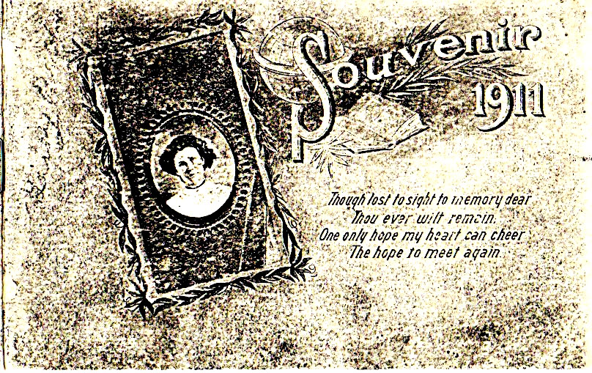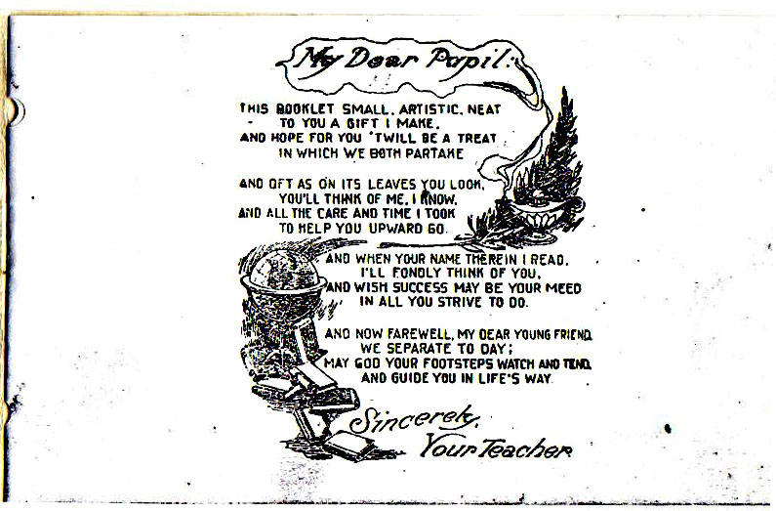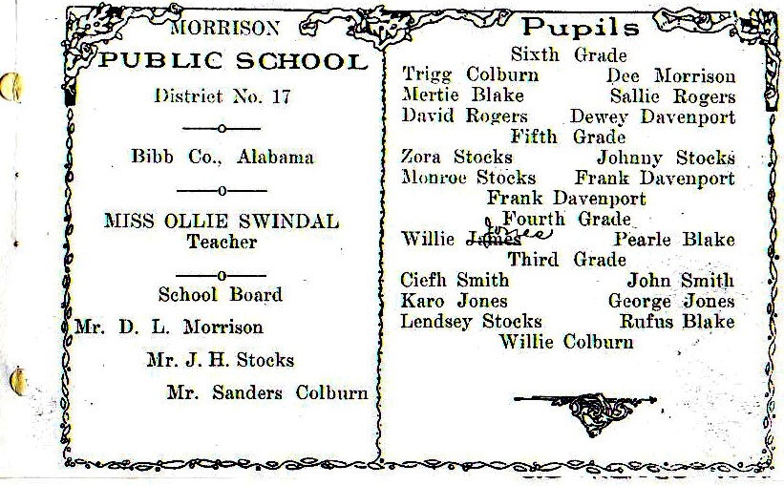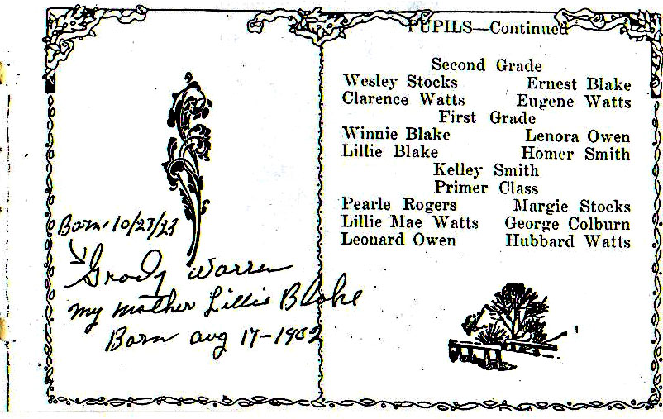
SIBLINGS : Sixth Grade: Myrtie Bell Blake (1894-1957); Fourth Grade: Bertie Pearl Blake (1896-1980); Third Grade: Rufus Blake (1898-1970);
Second Grade: Ernest Blake (1900-1953); First Grade: Lillie Blake (1902-1987).
COUSIN : First Grade: 2nd Cousin, Once removed - Winnie Day Blake (1903-1947) “being distraught over husband’s sudden death, she hung herself.” (source: Blakes of Bibb County, Alabama by Chester R. Johnson, 1988.) NOTE: book may have been Lillies & inherited by Grady.

